**Blowfly Visual System in the H1 Neuron: Differentiation of Random and Preferred Motion Stimulation**

By: Christian Bick and Nicholai Yonan

TA: Jeff Moore

UCSD Biophysics and Neurophysiology Course, Prof. David Kleinfeld

**Introduction:**

The visual system of the Blowfly, in our case *calliphora* and *sarcophaga,* can be easily studied due to the Blowfly’s abundance and small scale. The visual system of the Blowfly is comprised of numerous neurons, but we are interested in the H1 neuron; the H1 neuron is a relatively large neuron making it easy to find and record from with our equipment. Full-field visual motion in the regressive direction triggers the H1 neuron and the fly uses this to maintain equilibrium during flight. The H1 Neuron is located four synapses away from the retina, making it analogous to the cells in the visual cortex, another reason it is widely used to study visual systems [4]. This similarity led us to conduct an experiment that is comparable to an experiment that tested the ability of macaques to distinguish between random and coherent motion [1]. In the coherent motion experiment, macaques were presented with random dot motion in two dimensions, with varying levels of motion in a single direction. The macaques were then trained to choose the direction in which the coherent motion was traveling. Results varied from monkey to monkey, but a common trend signified that the macaques could differentiate and accurately choose the direction of coherent motion at levels of coherence at approximately 13 percent.

We hoped to accomplish the same thing; the main aim of our experiment was to find out how well the neuron could differentiate between random horizontal motion and horizontal motion in the preferred direction. Varying ratios of random motion and motion in preferred direction were presented to the fly in order to monitor this.

**Procedures:**

**I) Fly Preparation**

The Blowflies were ordered from several vendors; Ward’s Natural Sciences would send us a vile of 100 fly pupae, while our second vendor, Forked Tree Ranch, would send us hatching fly pupae. All the flies regardless of development were then place in a rectangular container with small dishes of sucrose and water in order to provide them with sustenance upon hatching.

Two days after the flies had hatched they were ready to be recorded from. A fly would be caught and placed into test tube; the test tube containing the fly was then placed into the freezer for approximately six to seven minutes. This procedure anesthetizes the fly, while anesthetized the fly’s wings and legs are removed. Hot wax is then used to secure the fly on a metal platform, this wax also serves to cover and prevent the movement of vestigial limbs that could remain from their previous amputation. The fly’s proboscis was used to secure the head in a position that would make the back of the head easier to access. Wax was placed on the proboscis which was then adjoined to lower abdomen of the fly, exposing the back of the fly’s head. A scalpel in conjunction with a microscope was used to remove the exoskeleton covering the back of the fly’s head, doing so exposed the inside of the fly’s head on the contra lateral side. The fly’s brain is covered with air sacks; which we removed, exposing the fly’s brain, the location of the H1 Neuron. Fly saline1 (See Appendix) was used to prevent the brain from drying up.

With the completion of the preparation, the fly was placed into the LED Arena to be recorded from. A small incision was made into its back as a reference for recording, after the incision was made; a 3ΜΩ electrode is used to record extra-cellular activity from H1.

**II) Stimulus Presentation**

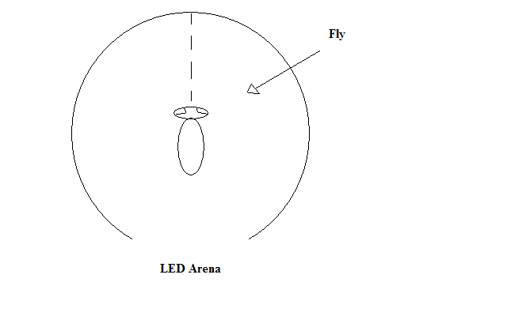A stimulus was presented to the fly via an LED Arena; this Arena was comprised of 96 LED columns controlled by 3 separate NI-DAQ™ cards. All together the 3 degree LED columns combined to create a 288 degree visual arc, which would surround the fly. The program MATLAB™ was used to control the LED columns via a NI-DAQmx C library. We would then vary the brightness of the cards, by breaking the LED column into sub-frames. Our timing setup was based on a 1ΜHz clock with a 1 kHz frame rate. This was presented with a varying brightness intensity of 1000. The brightness was then gamma-corrected to a gamma of 2.2.

Figure 1: Fly in LED Arena (Figure not to scale).

After the general layout of the stimulus was created it became possible to vary its arrangement and overall appearance. In order to test how well H1 differentiates between random motion and motion in the preferred direction, our stimulus would be presented with varying correlations of motion in the preferred and random orientations.

**III) Recording**

Recoding took place once the fly was placed in the arena and upon its exposure to full-field visual stimulation. A 3ΜΩ electrode was inserted into the back of the fly’s brain and ultimately its neuropile. The high resistivity of the electrode allowed us to measure over very minute areas within the nueropile thereby eliminating extra cellar noise from other neurons. This electrode was connected to an amplifier with a gain of 3000, which in turn was connected to a speaker. A reference stimulus consisted of a number of wide vertical bars moving in positive direction for 2 seconds and then reversed to move in the negative direction for 2 seconds. This was done to test whether or not we had been able to locate H1; which was signified by a repeated “clicking” sound on the speaker when the test signal moved in the preferred direction.

Upon locating the neuron, we would begin to send our desired stimuli to the LEDs. All of the fly’s response to our stimuli was recorded using MATLAB™ Data Acquisition Toolbox™. Chronux (Cold Spring Harbor Laboratory) was used to process the data [2/3]. The baseline of the raw data was first (using the locdetrend function from Chronux). All data was concatenated for spike sorting (using Chronux). Spikes were detected with a threshold of -3 standard deviations from the total data, a spike interval of 1ms was captured.

Waveforms were sorted with a modified version of Chronux 2.0, the automatically generated clusters were used. Spike counts were extracted and the ROC curves were calculated similar to the way they were done in [1].

**VI) Stimulus**

The stimulus presented to the fly was a mix of fixed direction horizontal line motion and random walk line motion. Coherence levels between the stimuli were varied by multiples of 10, (80:20, 70:30, 60:40, 50:50, 40:60, 30:70, and 20:80) for random: preferred motion. Coherent motion was presented to the flies at a constant 80 deg/sec, which is believed to be in the optimal range for H1’s recognition. The randomly moving bars moved according to a random walk that was updated with a frequency of 10Hz: Every 0.1s would reverse its movement direction with a probability of 50 percent.

We recorded a total of 175 trials from H1 each with random ratios of coherence levels. These 175 trials produced raw data mapping the H1 and other nuerons action potential voltage over time. The order of our stimulus delivery was the following: reference stimulus (in order to find the nueron), set of 25 trials, another test reference stimulus, set of 150 trials, followed by a final test reference stimulus, to validate the previous trials (after time some factors could lead to the loss of the nueron).

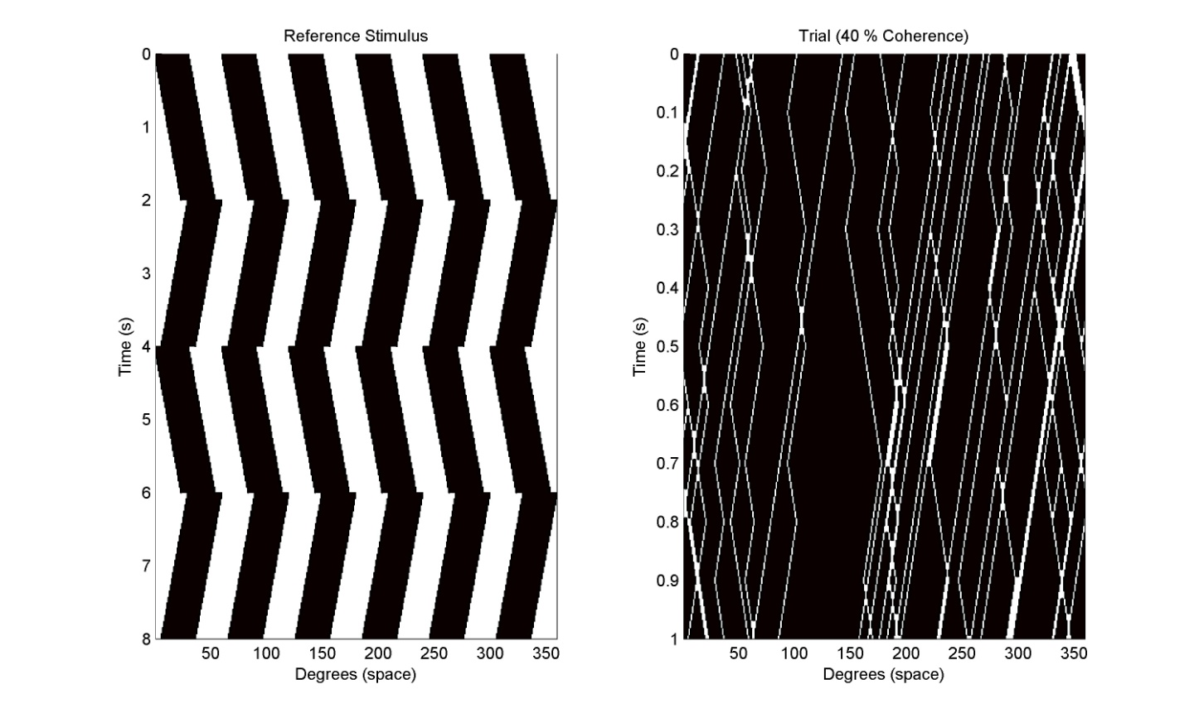**Results:**

Figure 1.2: Reference stimulus (left) and a sample experimental stimulus at 40% coherence (right). The x-axis denotes space in the visual field; time is denoted by the y-axis

**I) Raw Data**

The raw data came in the form of 1000’s of spikes overtime which is displyed in Figure 2. The raw data and more importantly the plot of spikes over time reveals that the number of spikes over time decreases, suggesting that the neuron is undergoing some form of adaptation. This should reduce the ability of the neuron to distinguish between the null and preffered direction because the distributions “merge.” The data is presented with that fault, however when assuming a linear decrease of firing rate, the qualitative results do not change. The waveform of the H1 nueron was calculated (Figure 3). The firing of H1 at zero seconds followed by the refractory period before it can fire again is clearly diplayed. A Raster plot was successfully created from the data, displaying the spike clusters against time.



Figure 2: Raw data, voltage changes over time (left) and on the right, the number of spikes over time.

Figure 3: Raster plots of spike clusters versus time (left), the waveform of the spikes (right).

**II) Processed Data**

As coherence increases the firing rate of the neuron increases (Figure 4). The Raster plots clearly show that the firing rate in the preferred direction increases as the coherence levels increase. Upon counting the spikes we were able to create histograms that would eventually lead to the creation of ROC curves (Figure 5). The ROC curves display the fact that increasing coherence levels correspond to a change in the distributions for the null and preferred direction shift in opposite directions. This is to be expected as the movement becomes more distinguishable, the neuron can more easily detect motion in the preferred direction while not responding to motion in the null direction. After quantifying all of the data (Figure 6), it is clear that starting at 20 percent coherence H1 can clearly distinguish directions with a certainty of 95 percent.

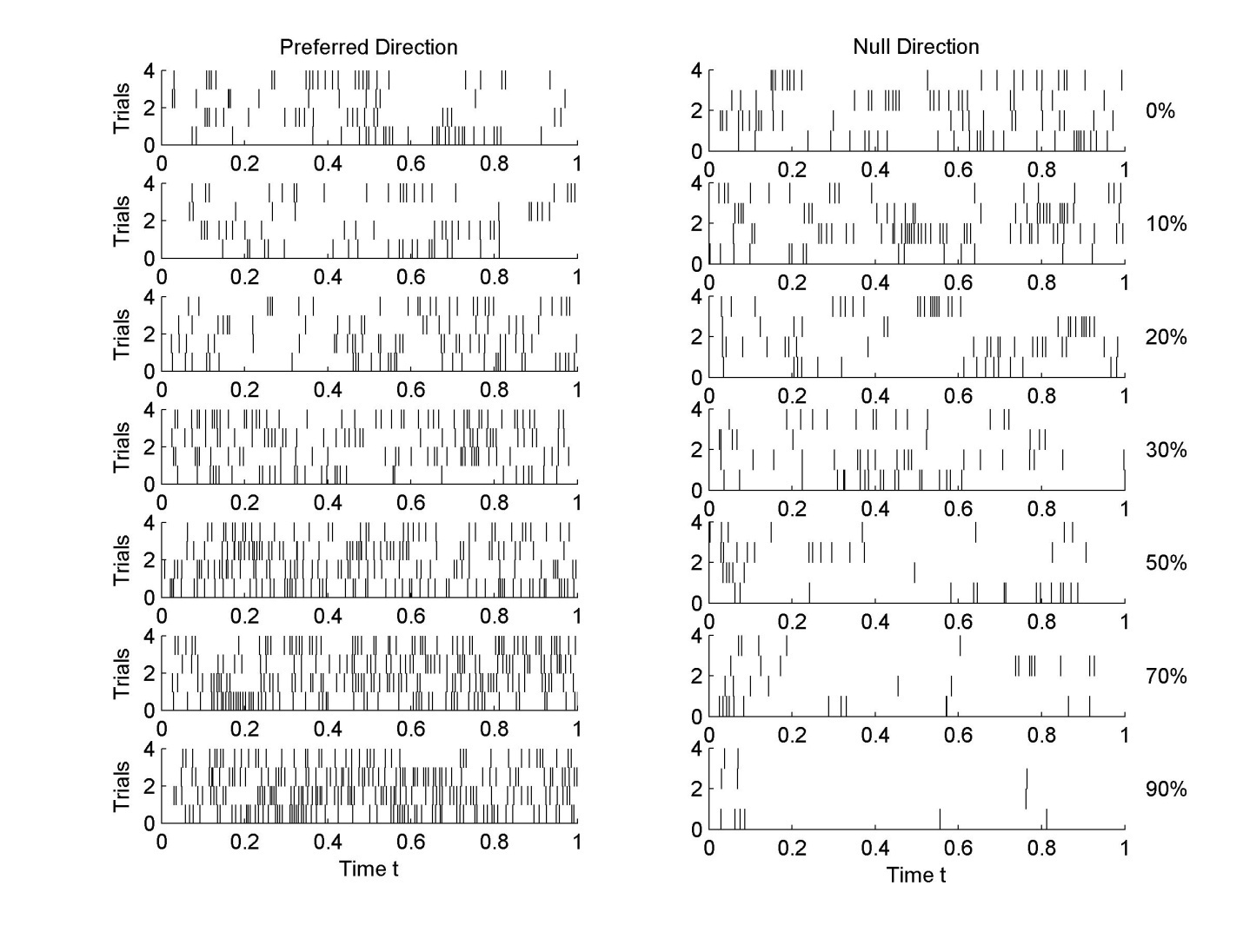

Figure 4: Raster plots of coherence levels versus firing rates in both the null and preferred directions of all 175 trials.



Figure 5: Number of trials v. the coherence levels of each trial and its direction of motion (left). The ROC curves outlining the point at which H1 can differentiate between motion in the preferred and null directions at varying coherence levels.



Figure 6: Plots displaying the proportion correct against the coherence levels. Although the proportion correct is random between 0-20 percent (approx. 50:50 in either direction), it is clearly visible that H1 can distinguish direction at coherence above that.

**Discussion:**

We started this experiment to test the abilities of the H1 neuron in the Blowfly (*calliphora* and *sarcophaga*), a key part of the fly’s visual system. More specifically we were trying to find the H1 nueron’s ability to differentiate between random and coherent motion. After 175 trials and the use of MATLAB™ and Chronux to analyze our data, we found that the H1 nueron is able to distinguish between random and coherent motion at levels of coherence as low as twenty percent, with an uncertainty of only five percent.

In the future, it would seem logical to test H1’s ability to distinguish between lower coherence levels to find its absolute threshold. A test of coherence levels of every interger between zero and twenty percent would be possible and could be used to find the absolute threshold of the neuron. We had also created a separate test in which a human could participate in trying to distinguish coherence levels as the fly was doing so, creating a benchmark by which the fly’s visual system can be compared to that of a human’s. But we lack suffiecient data on humans to present any logical result in our write-up.

**Appendix:**

## A1: Fly Saline from [6]

110 mM NaCl

5.4 mM KCl

1.9 mM CaCl2

20 mM NaHCO3

15 mM TRIS(base)

13.9 mM glucose

73.7 mM sucrose

23 mM fructose

## Adjust the pH to 7.2 at 25_C with 1 N HCl.

**References:**

[1] Britten, Kenneth H. Shadlen, Michael N. Newsome, William T. Movshon, J. Anthony. “The Analysis of Visual Motion: A Comparison of Neuronal and Psychophysical Performance.” The Journal of Neuroscience, December 1992, 12(12)

[2] Mithra, Partha. Bokil, Hemant. “Chronux.” 2008. Oxford University. 2 June 2009. <<http://chronux.org/>>

[3] Mithra, Partha. Bokil, Hemant. Observed Brain Dynamics. Oxford University Press, New York, 2008.

## [4] Eckert, Hendrik. “Functional Properties of the HI-Neurone in the Third Optic Ganglion of the Blowfly, *Phaenicia.”* (1980)J. Comp. Physiol. 135, 29-39

## [5] Wai Pang Chan, Frederick Prete, Michael H. Dickinson. “Visual Input to the Efferent Control System of a Fly’s “Gyroscope.” Science “1998”: Vol. 280. no. 5361, 289 – 292

[6] T. M. Brotz, M. Egelhaaf, and A. Borst. A preparation of the blowfly

(Calliphora erythrocephala) brain for in vitro electrophysiological and pharmacological studies. J. Neurosci. Meth., 57:37–46, 1995.